|  |
| --- |
| Close-up image showing the leaf-sides of two oversized books side-by-side on a bookshelf, with additional books in soft focus background |
| **TRAINUAL**  Training Management System |
| |  |  |  | | --- | --- | --- | | Link: |  |  | |

API - <https://github.com/Sasikumar-sasi/TMSAPI>

Front End Files - <https://github.com/Sasikumar-sasi/TMSClient>

**Developers:**

1. Sasikumar S
2. Vikash R
3. Bharath G
4. Jeevanath J
5. Saravanan J

**Topic: Training Management System**

**Project Abstract:**

* Training Management System is specifically developed for Trainees for Accessing the Assessment through Online and view the assessment scores.
* Training activities that learners are undertaking are aligned with duties, roles and responsibilities;
* Training delivery is effective and efficient – i.e., only includes activities that add value, uses the most cost effective technologies; and maximizes the use of personnel and resources.

**Purpose:**

* To automate the training management process without any physical human interaction.
* To make the training management process accessible anywhere to the employee.
* To allow the trainee to update their profile and view the assessment , upload the answer script and assessment scores.
* To allow the admin to efficiently manage their database and maintains the relationship in an effective manner.
* To maintain data consistency and integrity.

**Objectives**

* The project “Trainual” is aimed to develop to maintain the day-to-day activities , view the HR, trainer manager, trainer and trainee.
* To computerize all details regarding HR, trainer manager, trainer , trainee details.
* Schedule the assessment for trainee and view the assessment by HR , trainer manager and trainer.

**Mandatory Modules:**

* Admin
* HR
* Trainer Manager
* Trainer
* Trainees
* Assessment
* Scores

**Admin Module:**

* Admin ID
* Name
* Phone number
* Email ID
* Password

**HR Module:**

* ID
* Name
* Phone number
* Experience
* Education qualification
* DOB
* Address
* Department
* Position
* Email ID
* Password

**Trainer Manager Module:**

* ID
* Name
* Phone number
* Experience
* Education qualification
* DOB
* Address
* Department
* Position
* Email ID
* Password

**Trainer Module:**

* ID
* Name
* Phone number
* Skill set
* Experience
* Education qualification
* DOB
* Address
* Department
* Position
* Email ID
* Password
* Trainer Manager(FK)

**Trainees Module:**

* ID
* Trainer Name(Fk)
* Name
* Phone number
* Mapped TO
* Batch
* Education qualification
* DOB
* Address
* Department
* Position
* Email ID
* Password
* Assessment(FK)
* Scores(FK)

**Assessment Module:**

* Assessment ID
* Assessment Language
* Assessment Name
* Batch (FK)
* Date
* Duration
* Time
* Total Scores
* Questions File
* Answer files

**Scores Module:**

* ID
* Assessment ID(FK)
* Trainee ID(FK)
* Scored Marks

**Admin Module:**

* In this module the admin will be able login by entering ‘login id’ and ‘password’.
* The ‘login id’ and ‘password’ will be inbuilt for admin.
* The Admin after logged in will be directed to a new page. In that page Admin was Create

a new HR, Trainer and Trainee using there details.

* Admin was Provide a ‘Login id' and ‘Password’ to a new HR,Trainer and Trainee.
* They can use the login id and password to Login.

**Modules:**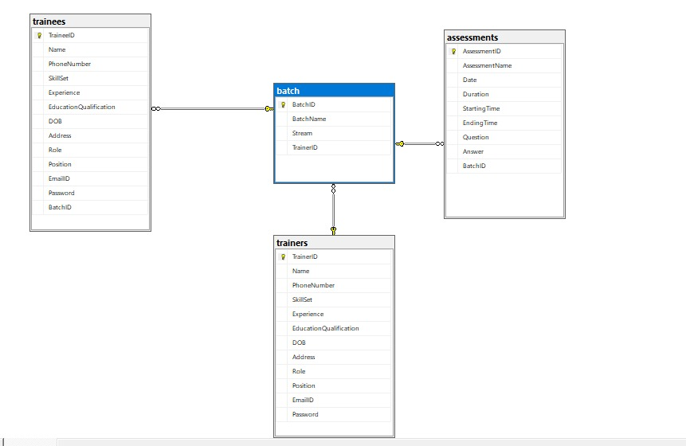

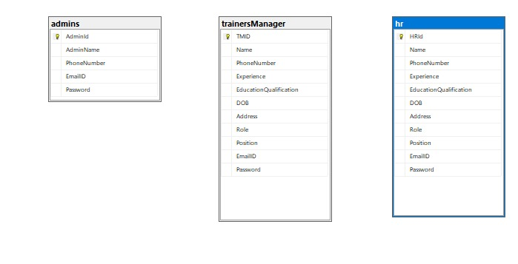

**Sample Output Screen for reference:**

**Admin Login:**

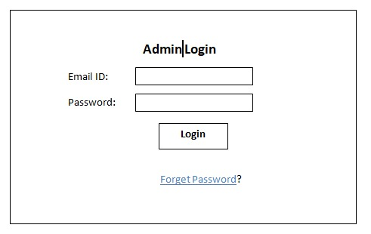

**HR Module:**

* HR gets login with the username and password given by the admin.
* They can update their profile using the update profile button where the details are updated along with their password.
* They can add new trainer which has attributes like email id, position and password.
* They can add new trainer manager which has attributes like email id, position and password.
* They can add new trainee which has attributes like email id, position and password.
* Whenever a trainer manager is added, they can view the trainer and trainee profiles.
* Whenever a trainer manager is assign a assessment. they can view the assessment.

**HR Login:**

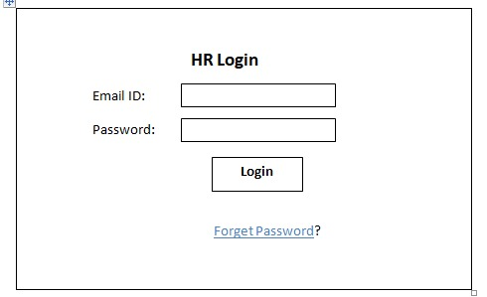

**HR Registration:**

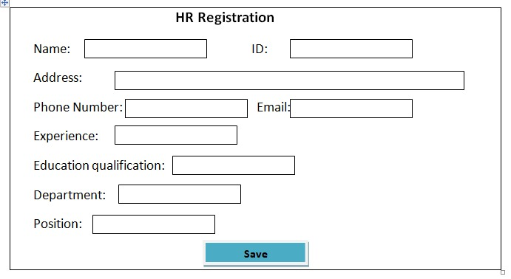

**Trainer Module:**

* Trainer gets login with the username and password given by the HR.
* They can update their profile after they can login.
* They can view the trainee profile.
* They can view the assessment after Training manager schedule the assessment and Trainer can upload the Assessment Question Paper.
* Trainer can view the Assessment and they give the Score for that Assessment.

**Trainer Login:**

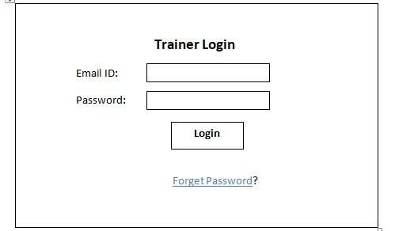

**Trainer Registration:**

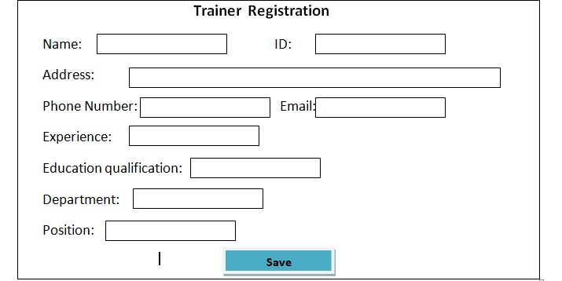

**Trainee Module:**

* Trainee gets login with the username and password given by the HR.
* They can update their profile after they can login.
* They can View the Assessment after Training manager schedule the assessment and Trainer can upload the Assessment Question Paper.
* After complete the Assessment Trainee can Upload the Answer Script.
* Trainer can view the Assessment and They can Give the Scores for Assessment. After Trainer give the Assessment Score, Trainee can view the Scores of Assessment.

**Trainee Login:**

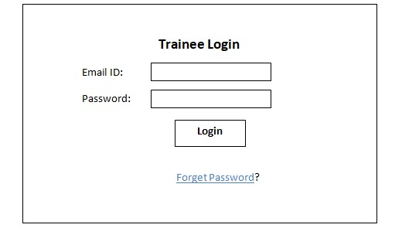

**Trainee Registration:**

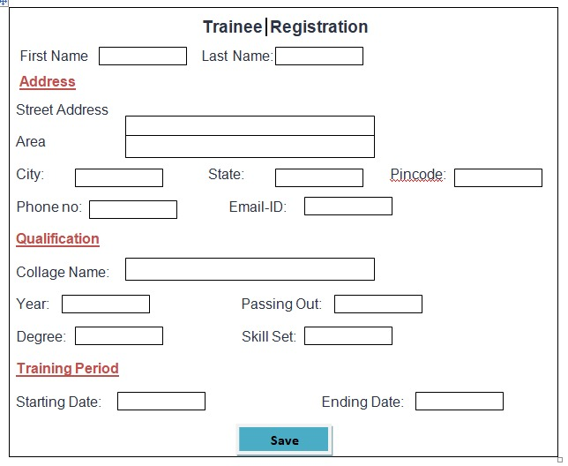

**Schedule Assessment:**

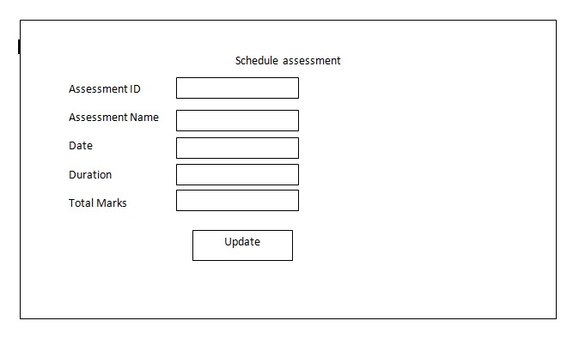

**View Score:**

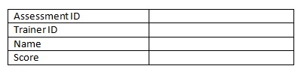

**DashBoard Admin:**

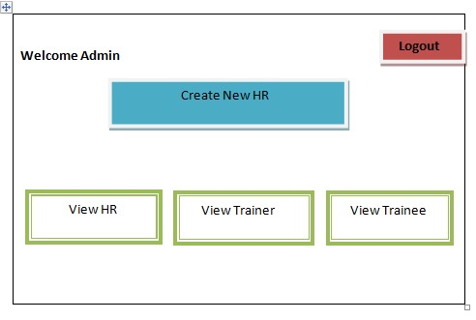

**HR DashBoard**

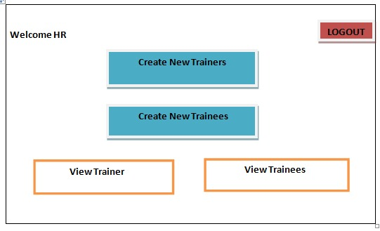

**Trainer Manager Dash Board**

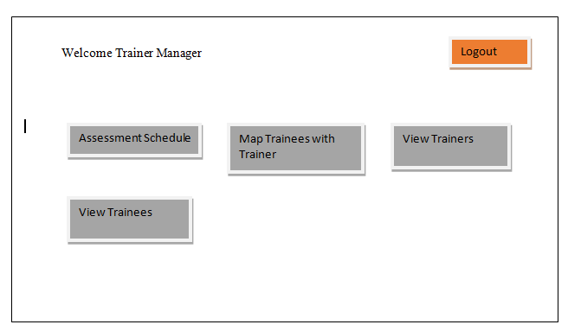

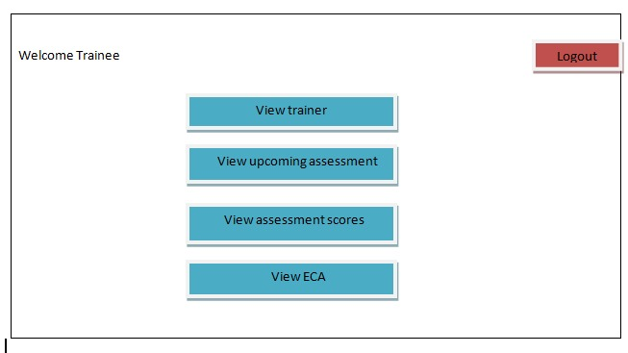

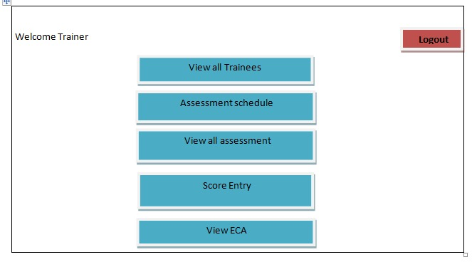

**Trainer Manger Module:**

* Trainer Manager gets login with the username and password given by the HR.
* They can update their profile after they can login.
* They can view the trainer and trainee profile.
* They can create a new batch and map the trainee to this trainer and also they can view the batch.
* They can schedule the assessment date with their batch. Because those particular batch students only access this assessment and also they can view the assessment.

**Output:**

Home Page for all Users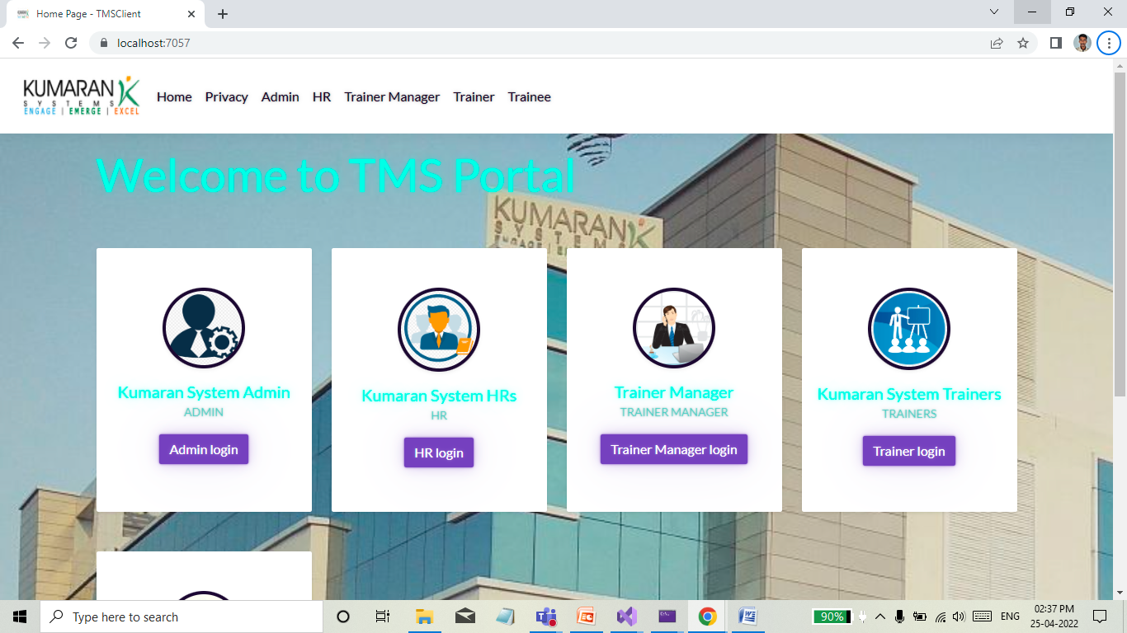

**Admin Login**

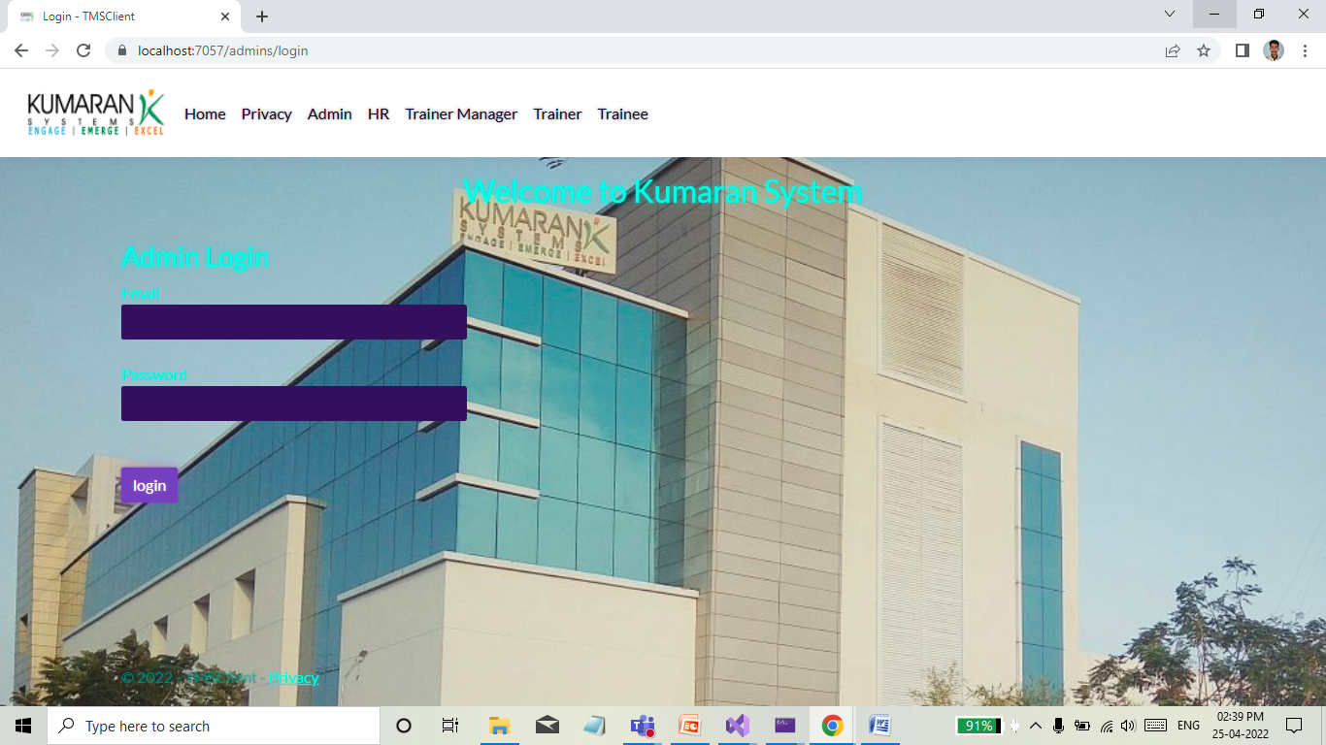

Admin Dash Board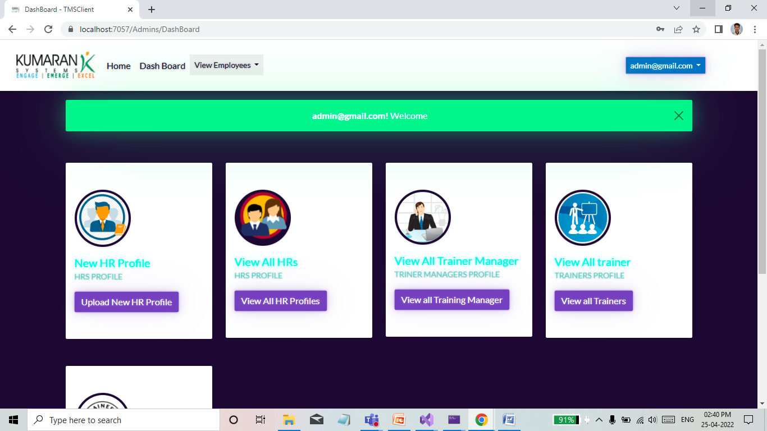

Create New HR Profile

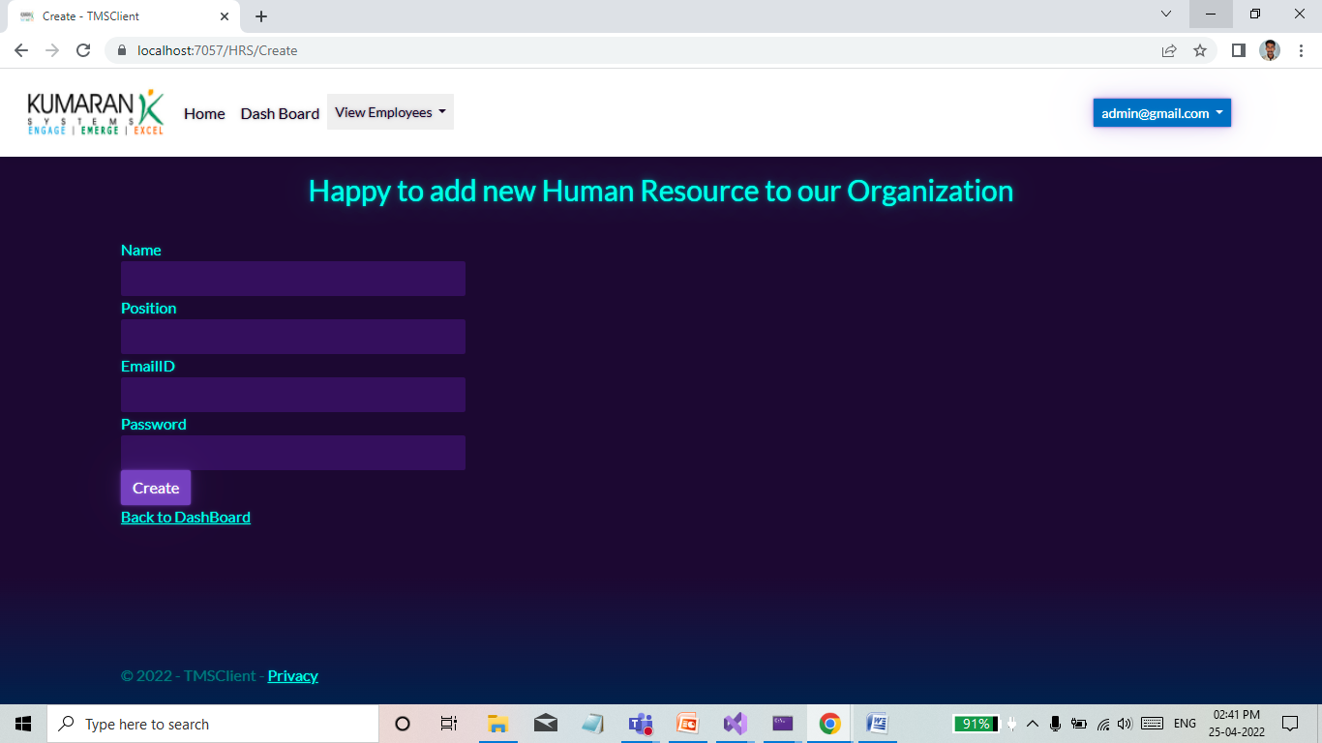

View All trainer manager in our organization:

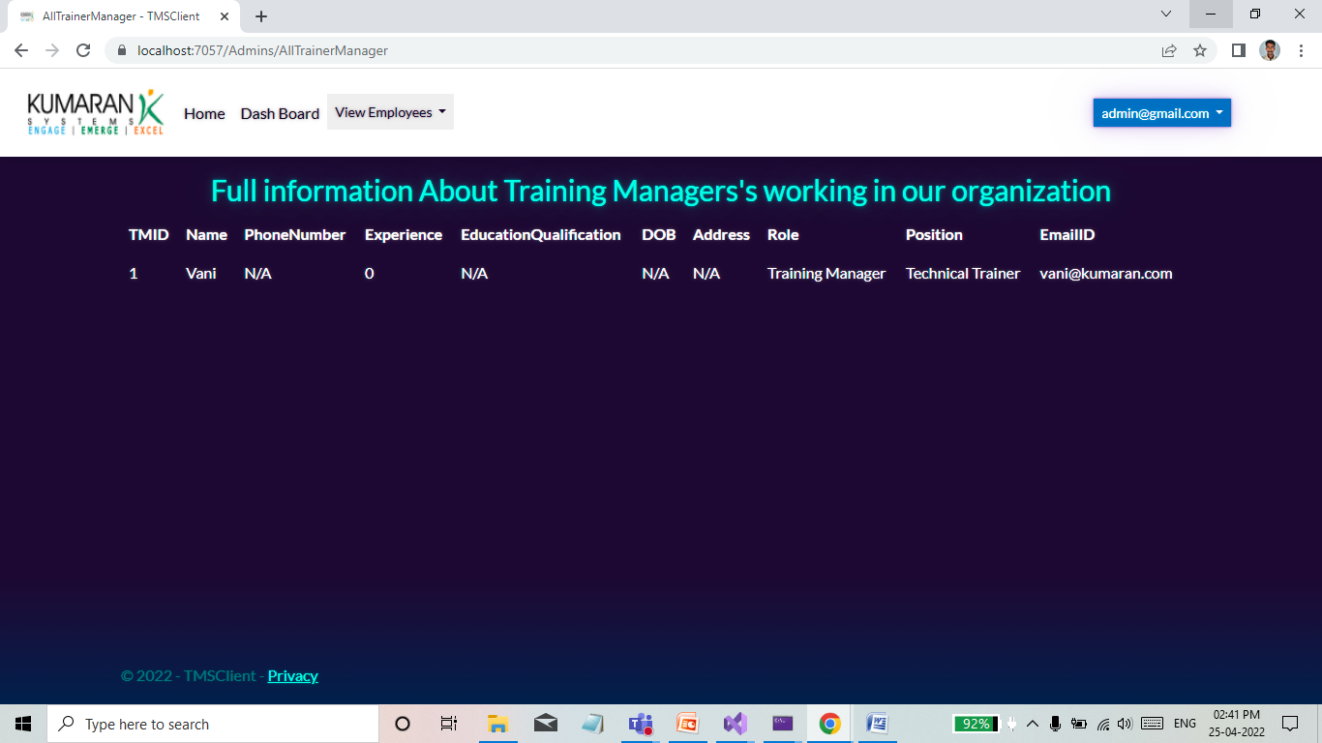

View All trainer in our company:

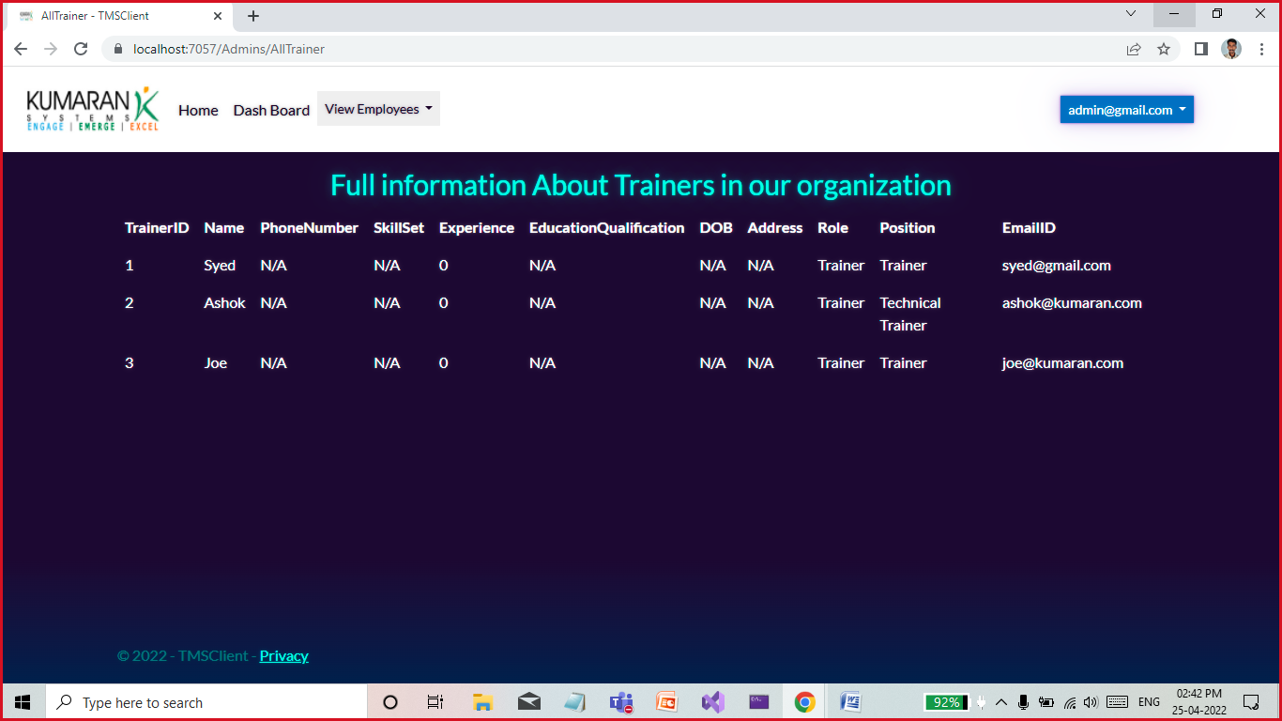

View all trainees

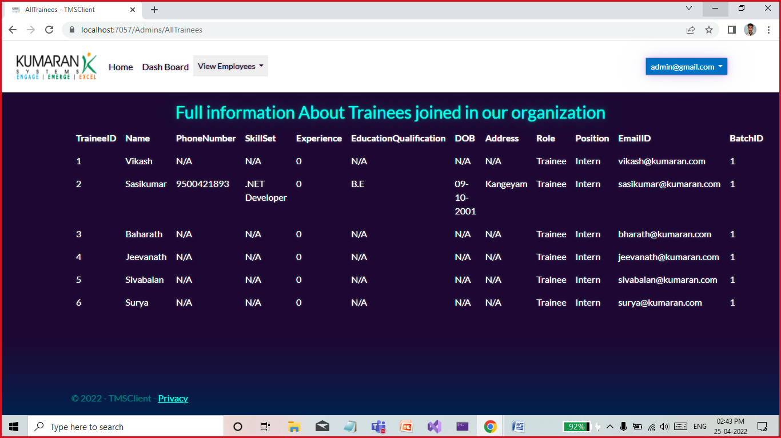

Update their profile and logout option

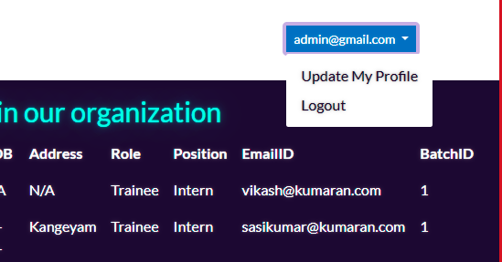

Update admin profile:

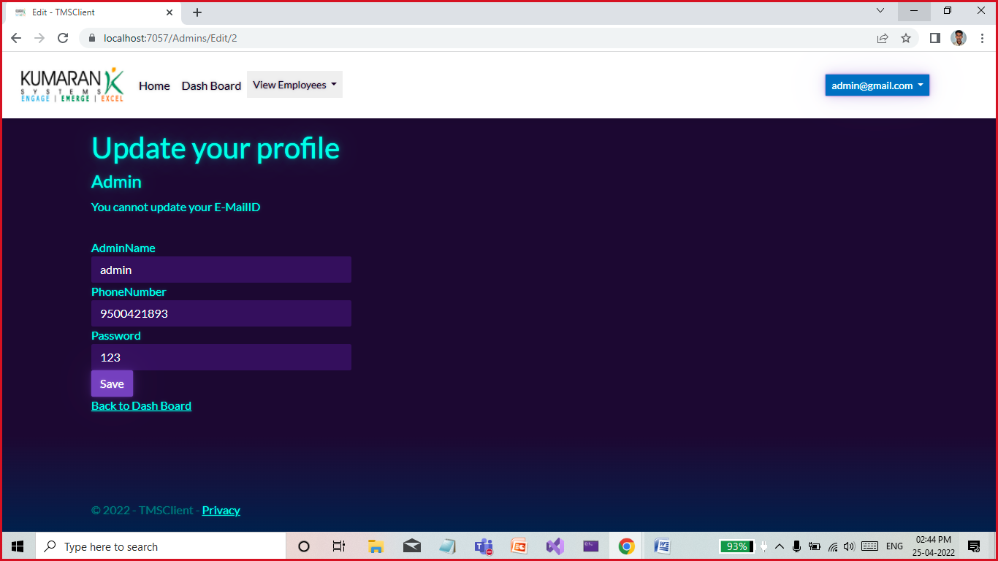

**HR Login**

Login Page

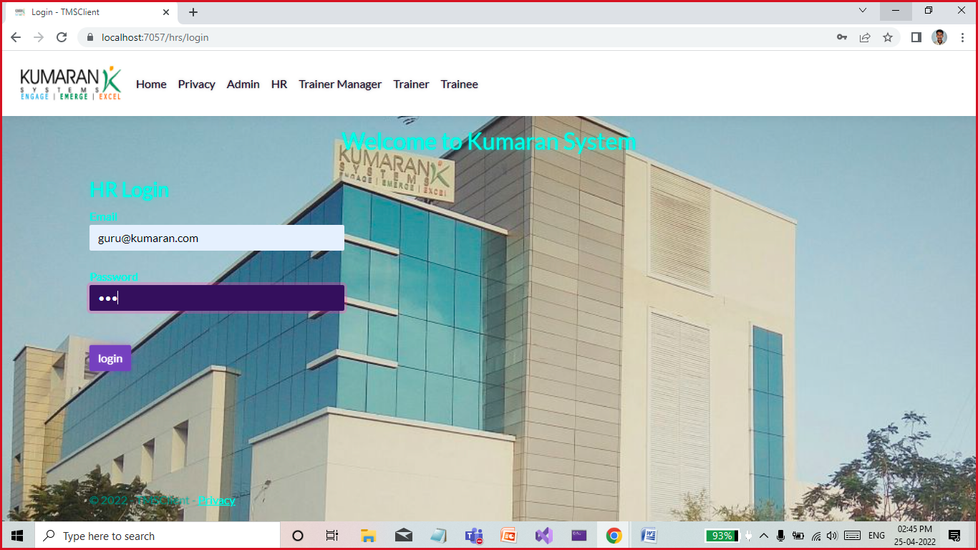

Dash Board for HR

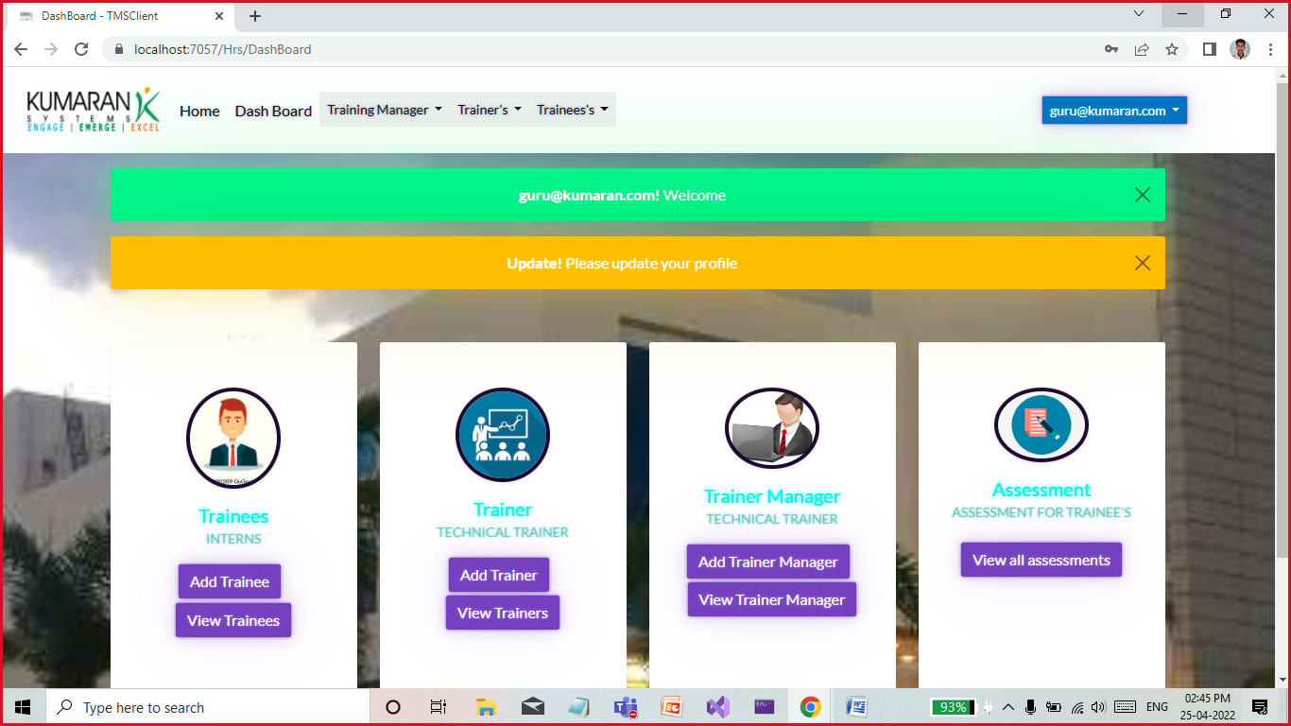

HR can add Trainee, Trainer Manager and Trainer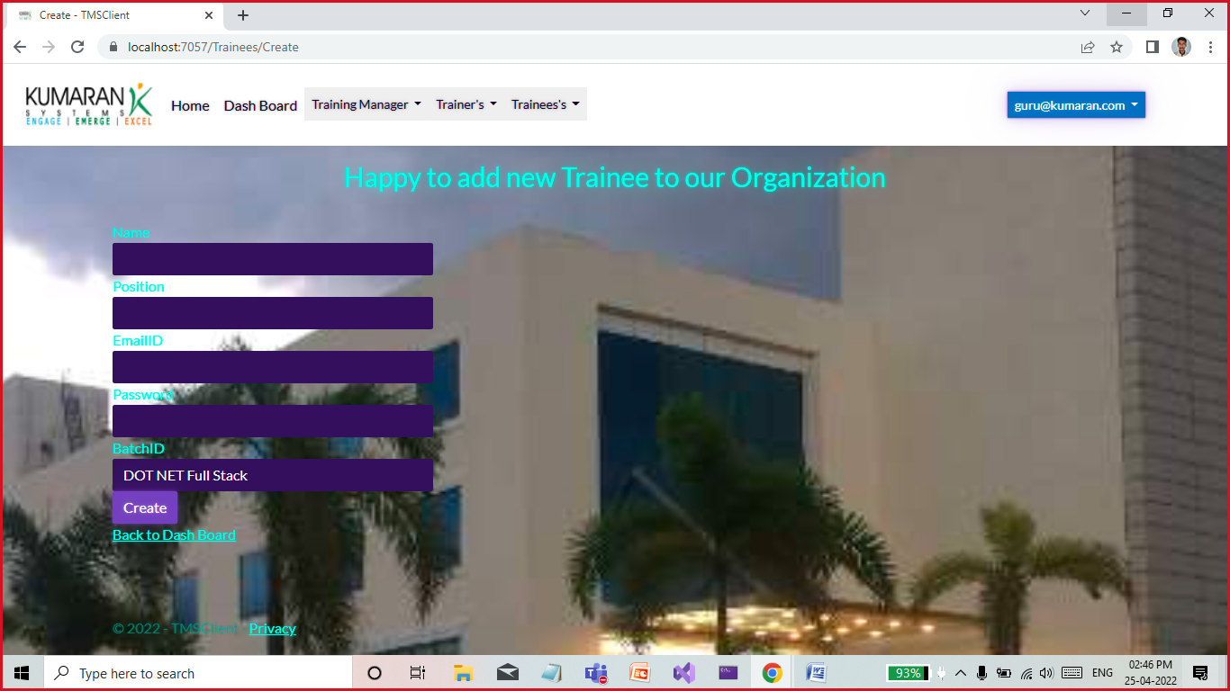

And view All employee based on position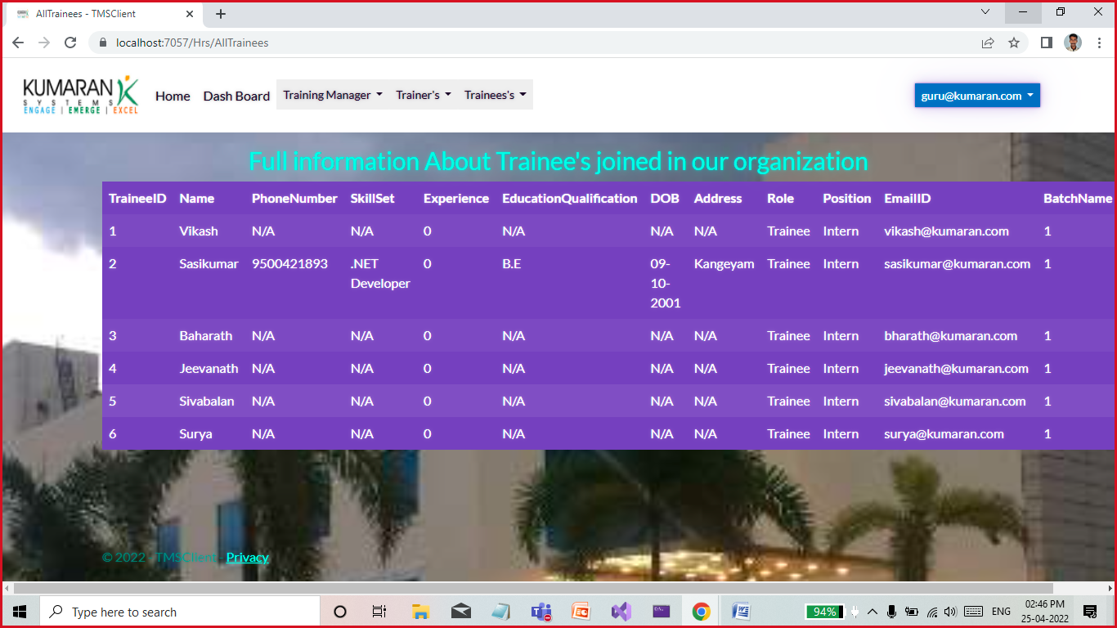

View Trainer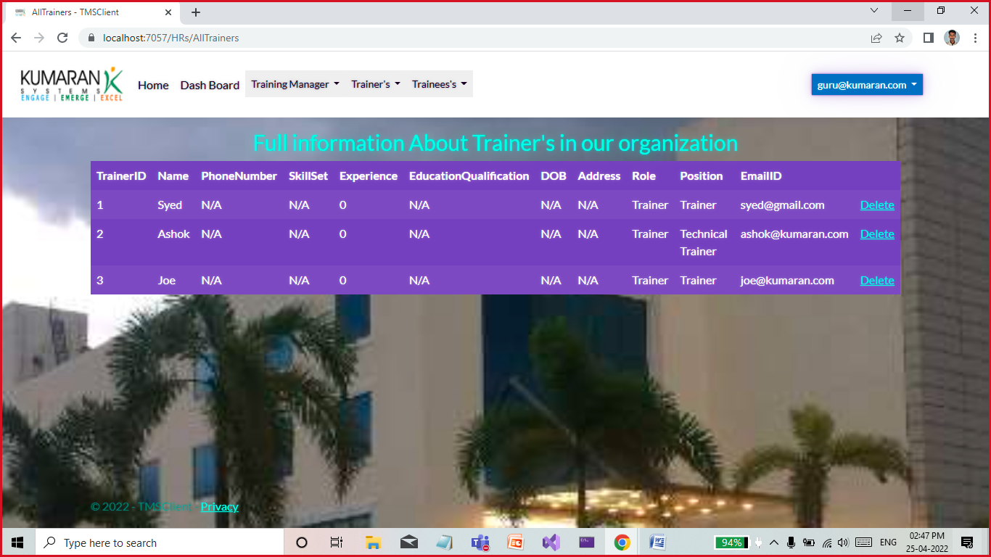

View all trainer manager:

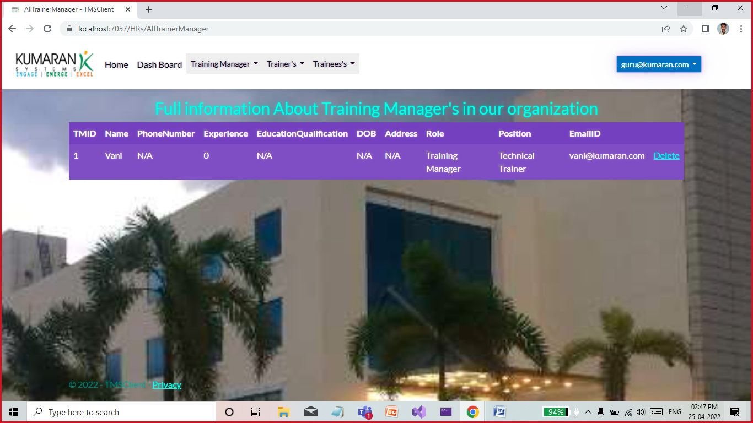

View all assessments:

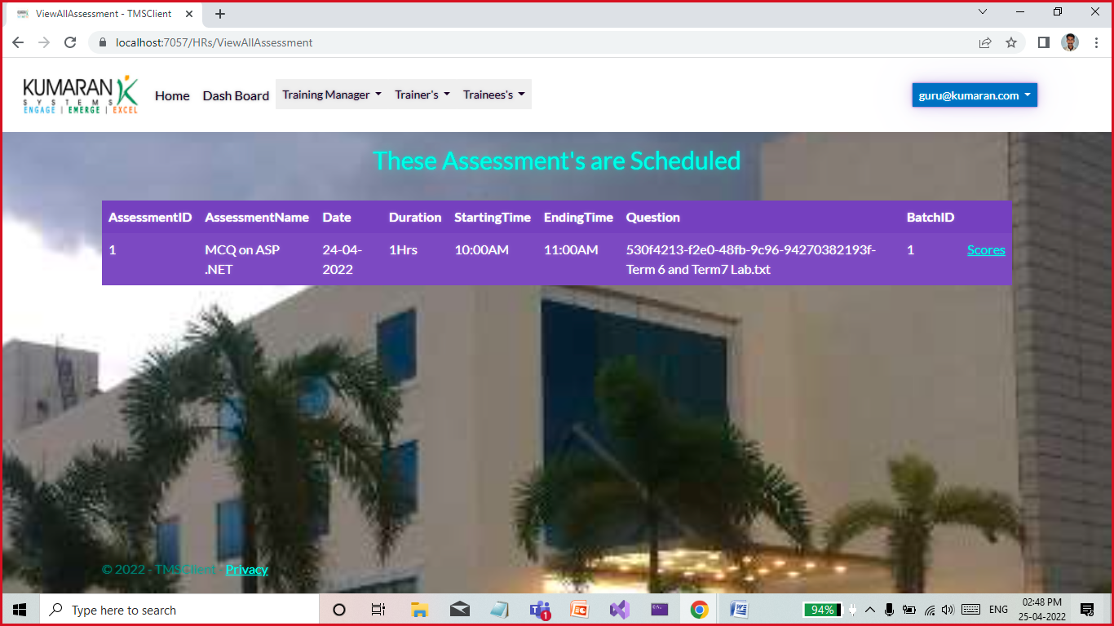

View all trainee scores based on assessment:

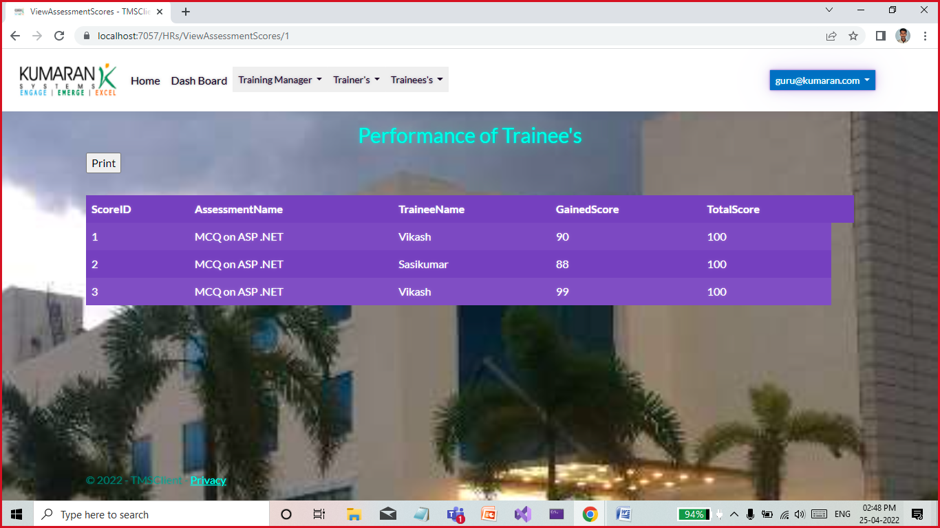

And print these scores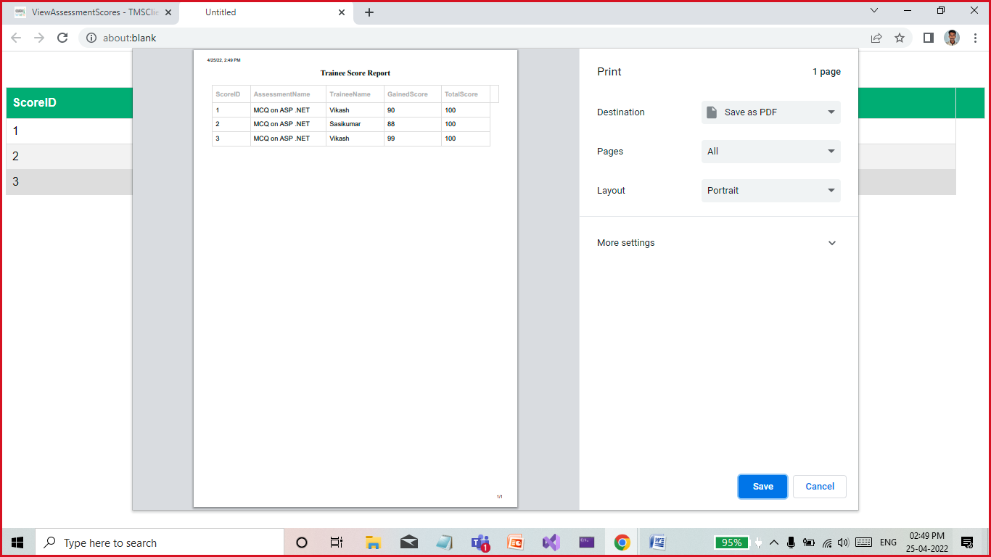

Complete their profile:

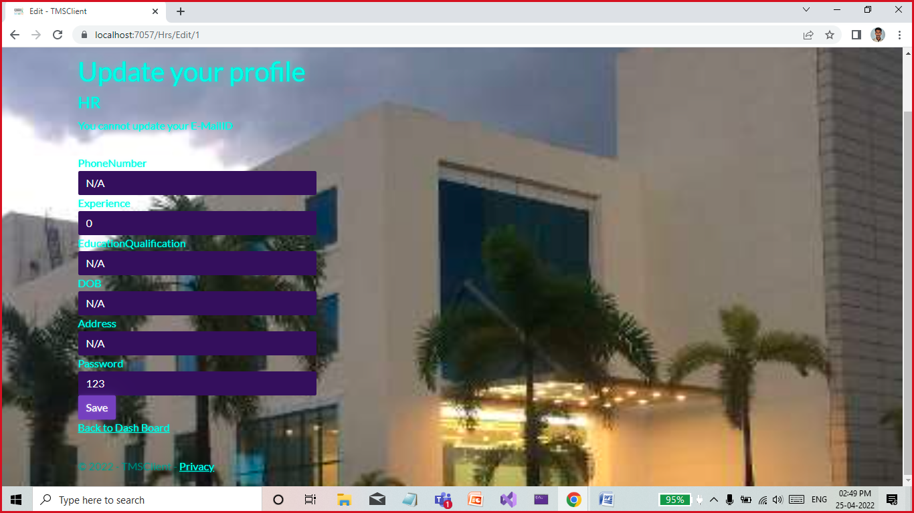

**Trainer Manager**

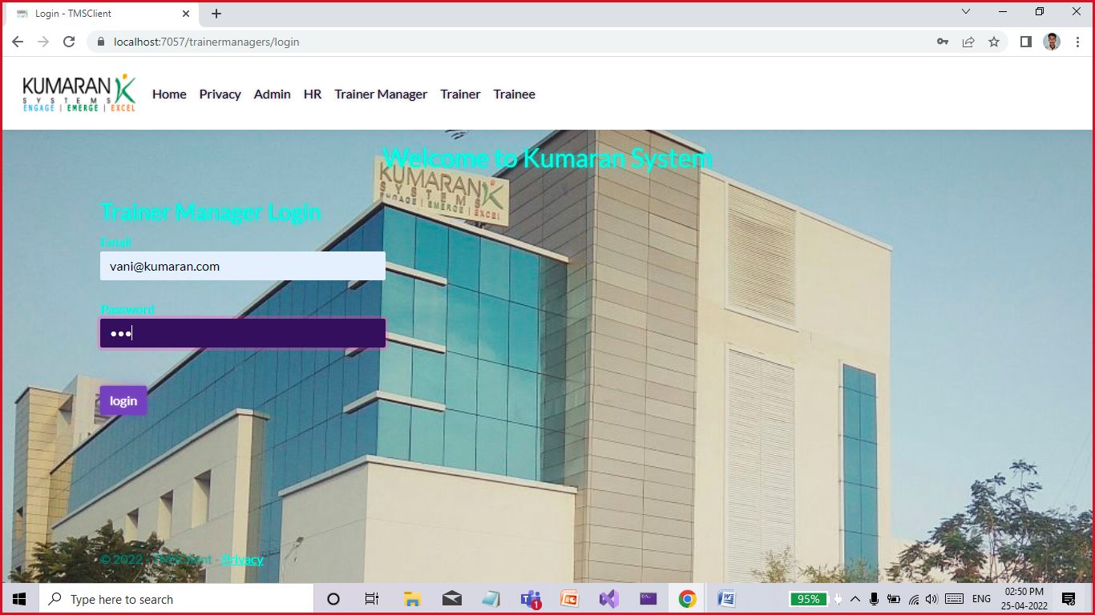

DashBoard for Trainer Manager:

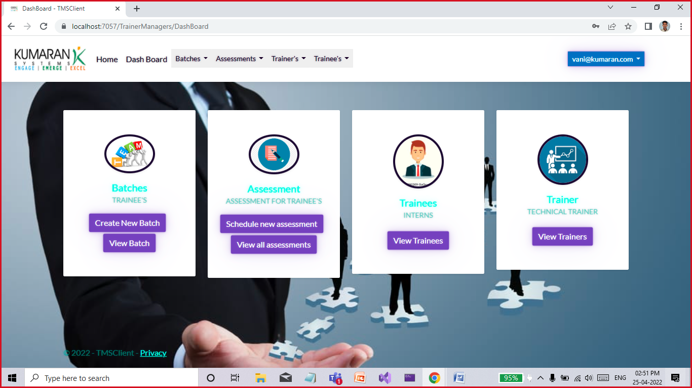

Create Based and select Trainer and Stream:

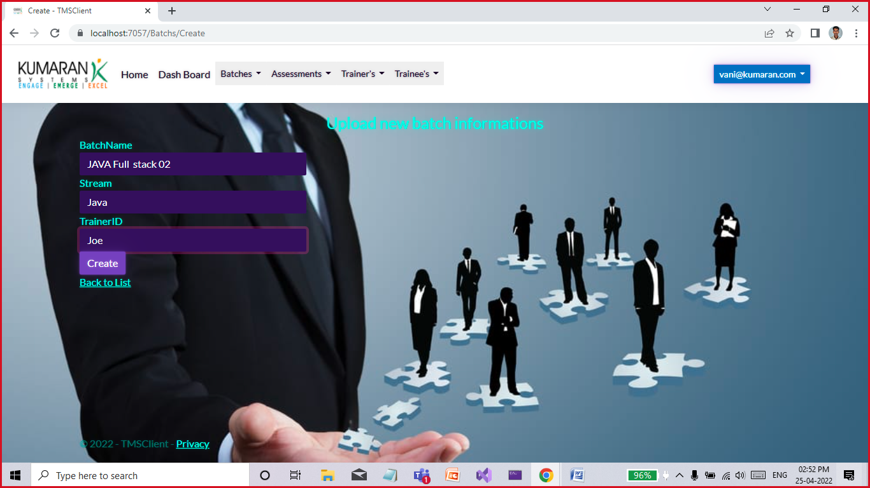

View All batch

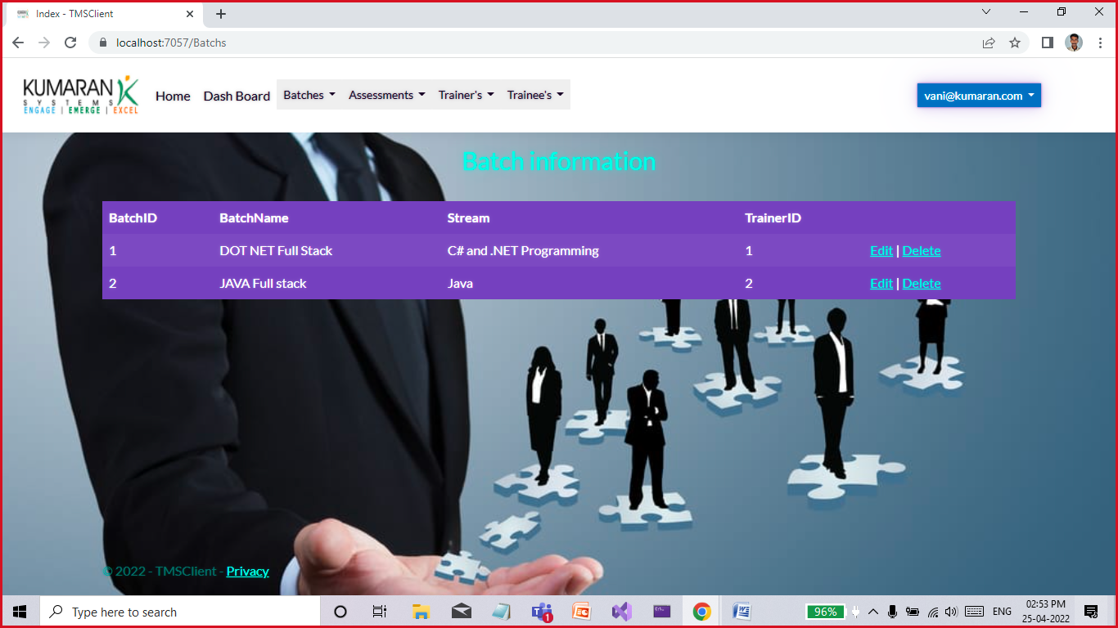

This page helps to create assessment schedule:

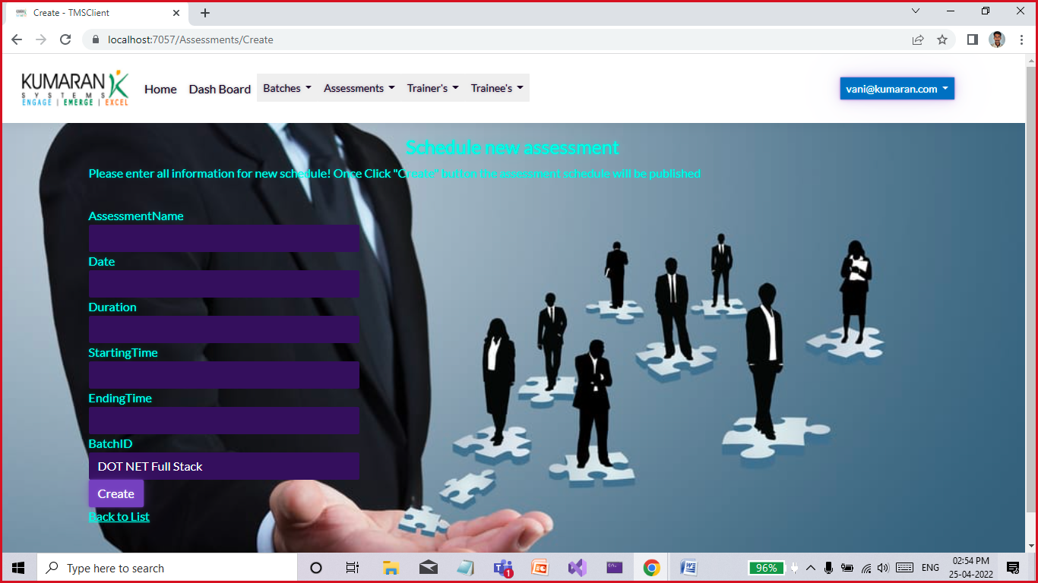

And also view all assessments scheduled

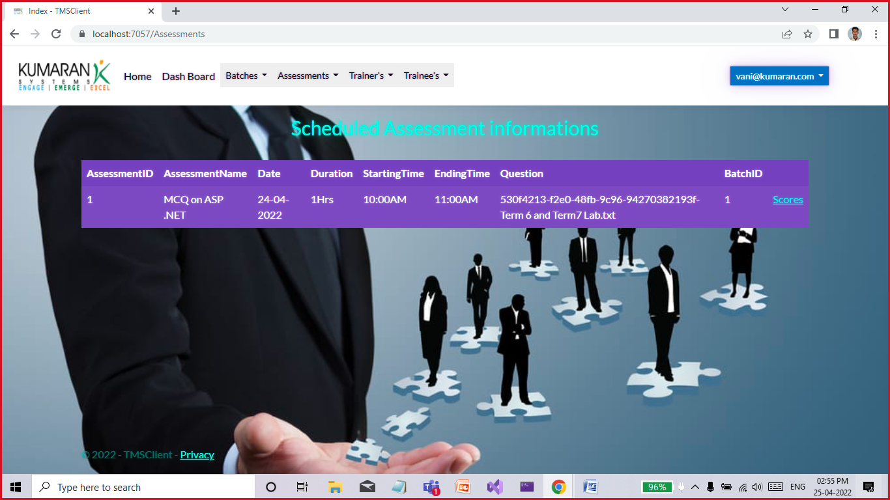

View trainees scores also

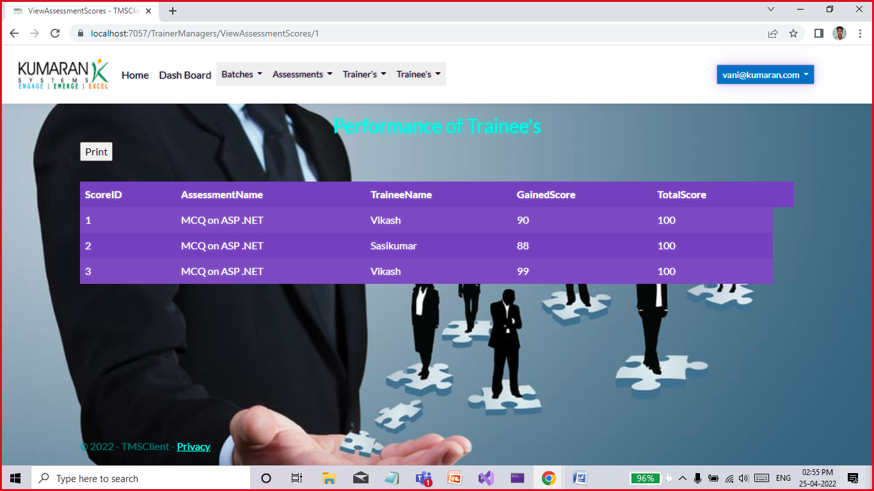

All trainers

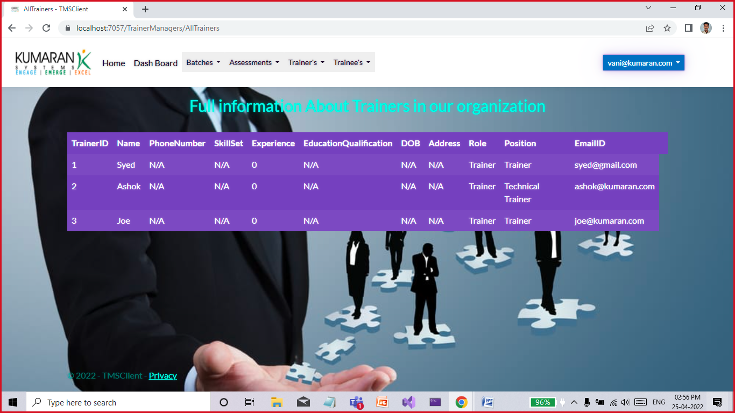

**Trainers Portal**

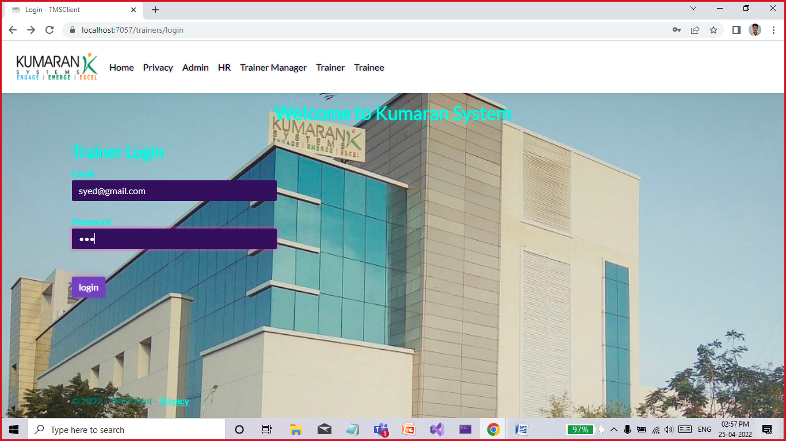

Dash Board for Trainer

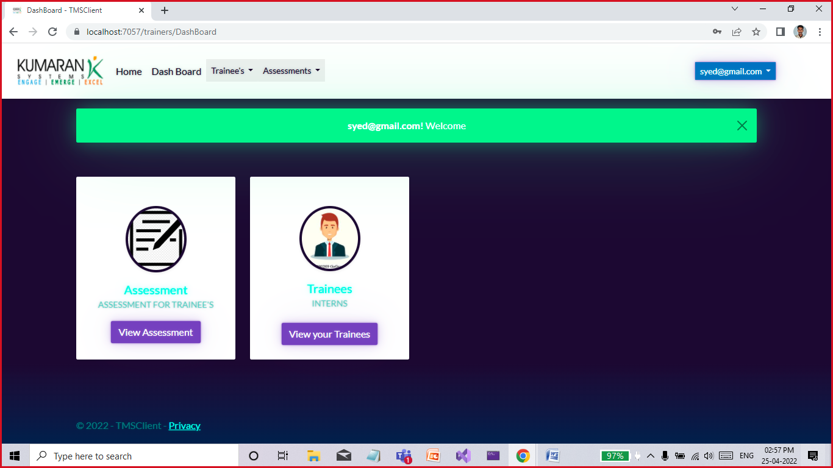

Trainer can view Scheduled assessment from Trainer Manager:

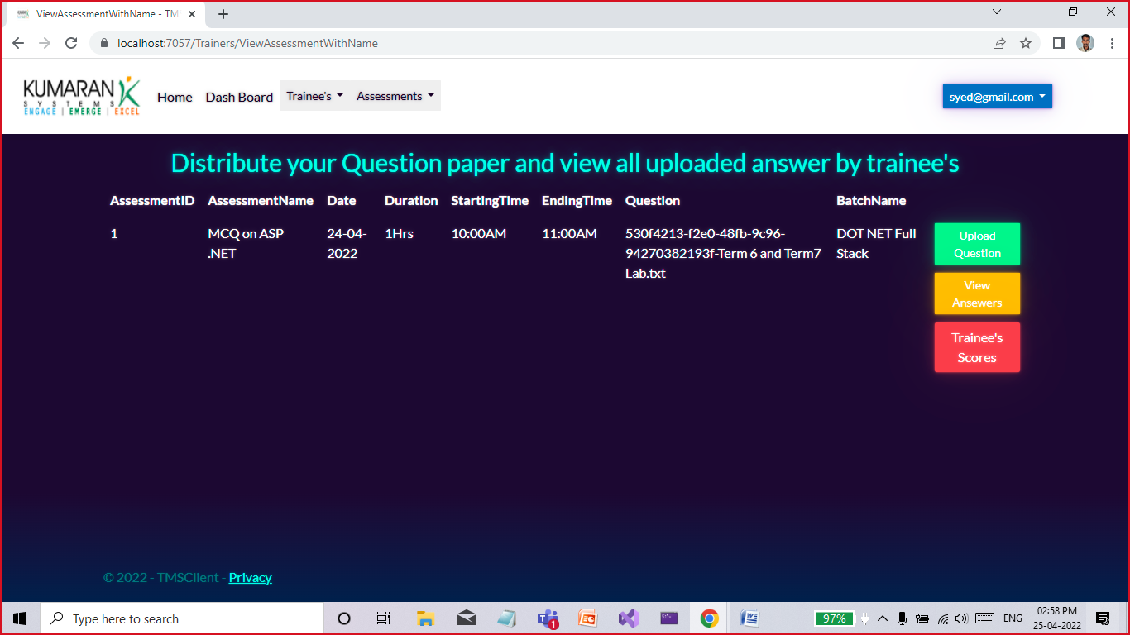

From this page trainer can Upload Questions and Download the answer script uploaded from trainee

After evaluation upload the scores for trainee’s

Question Upload:

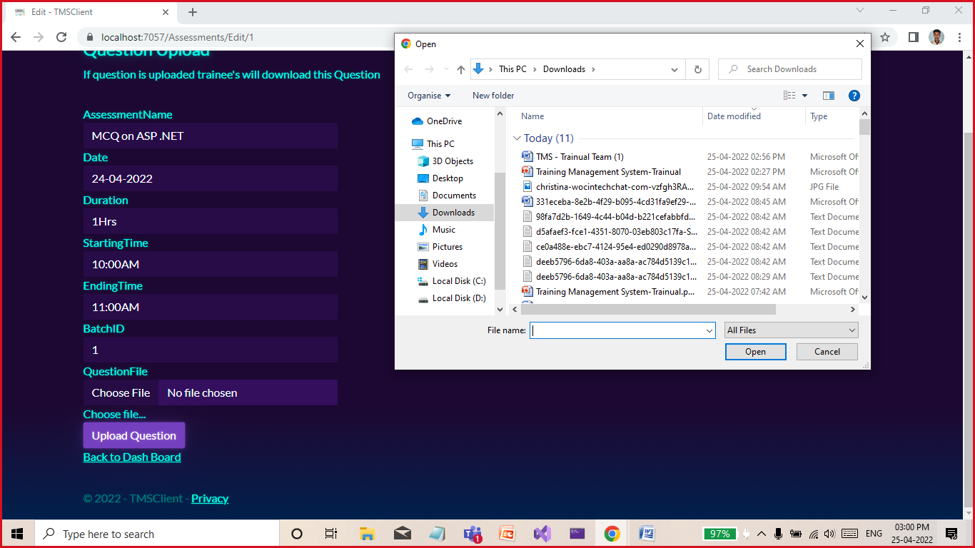

Trainees uploaded answer scripts,. Trainer will download this scripts and evaluate this files

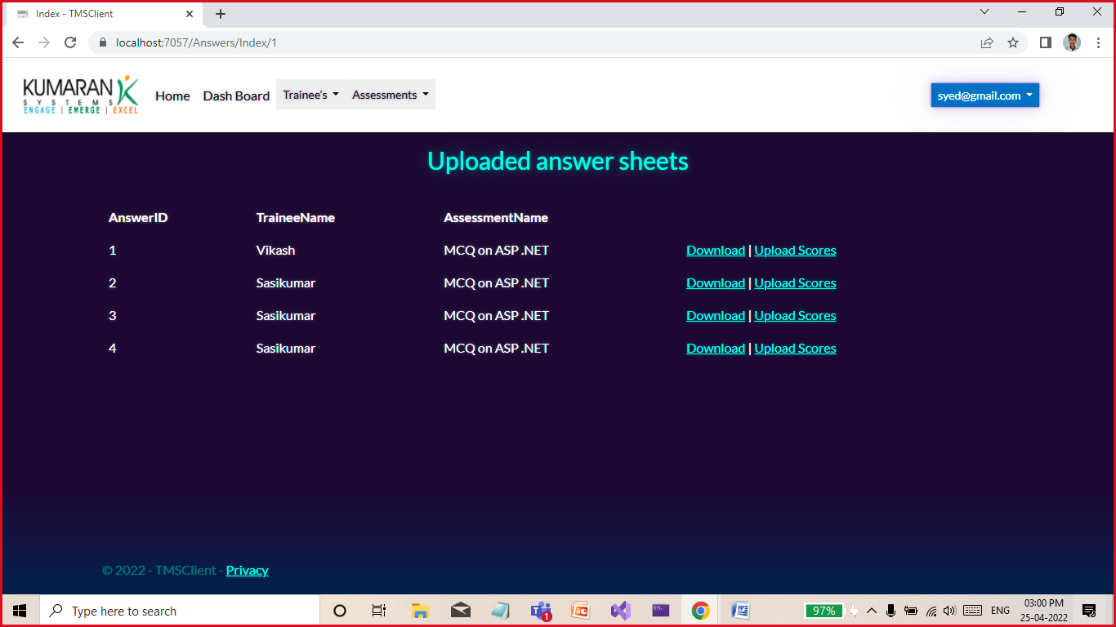

And upload scores

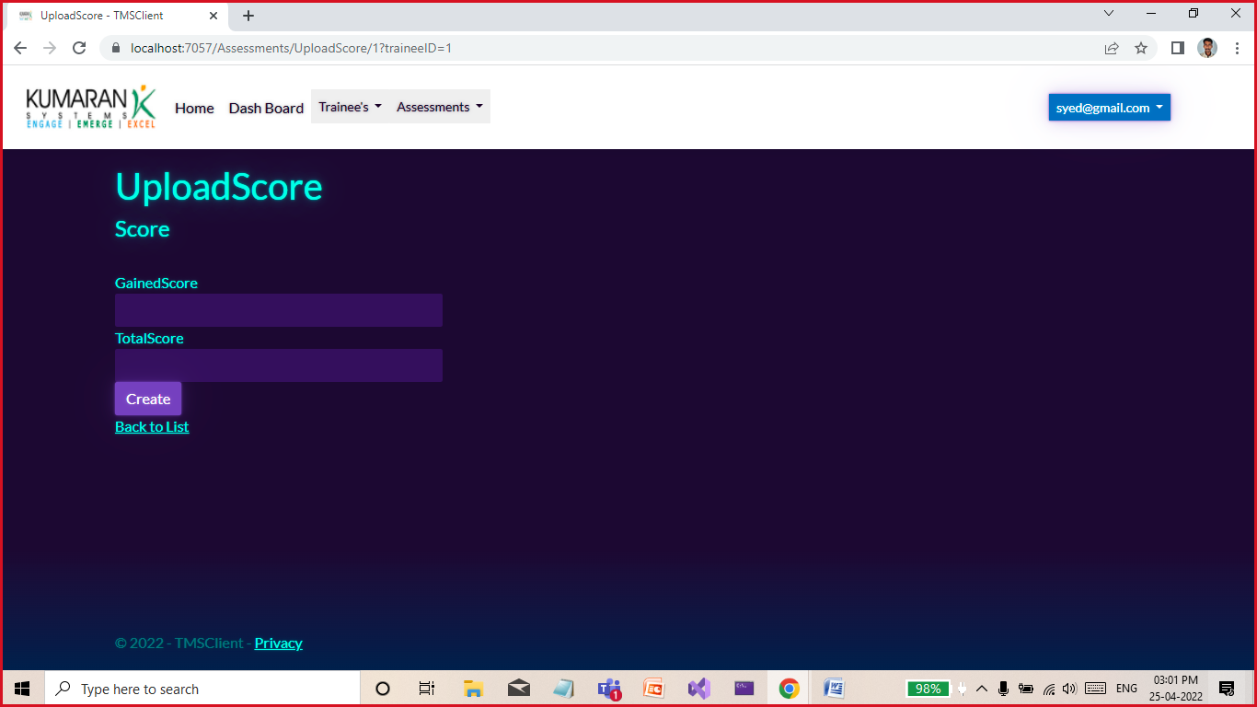

**Trainee Portal**

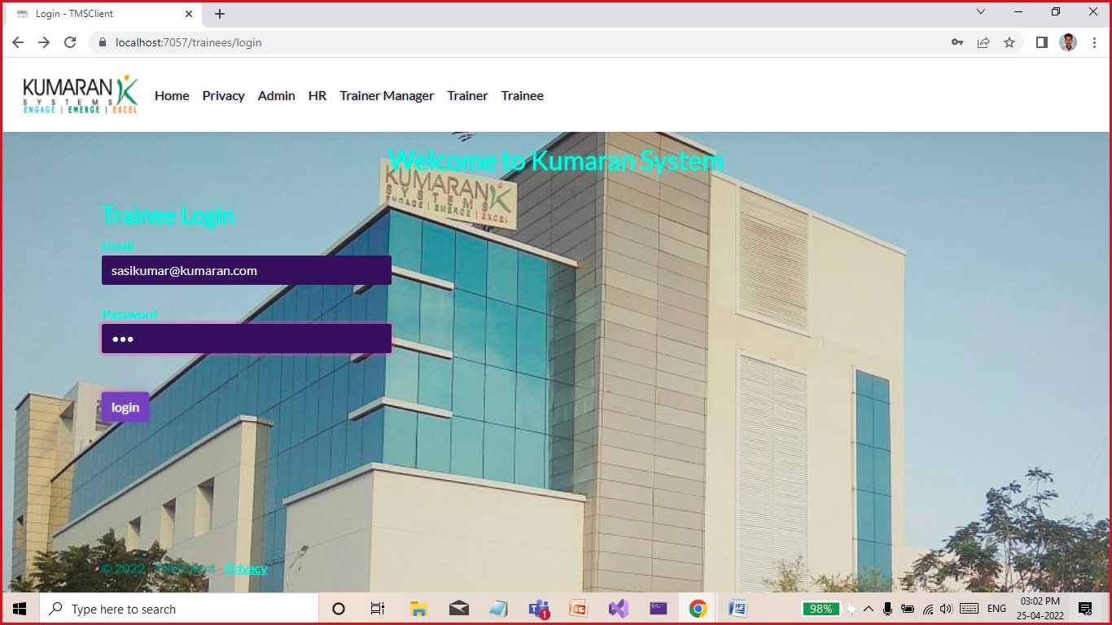

Dash Board for trainee

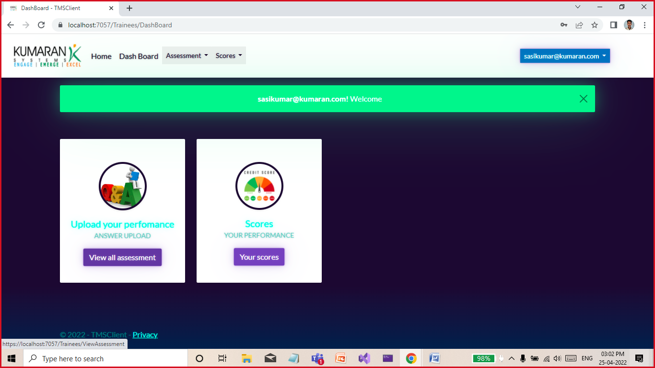

View all assessment assigned for these particular trainee:

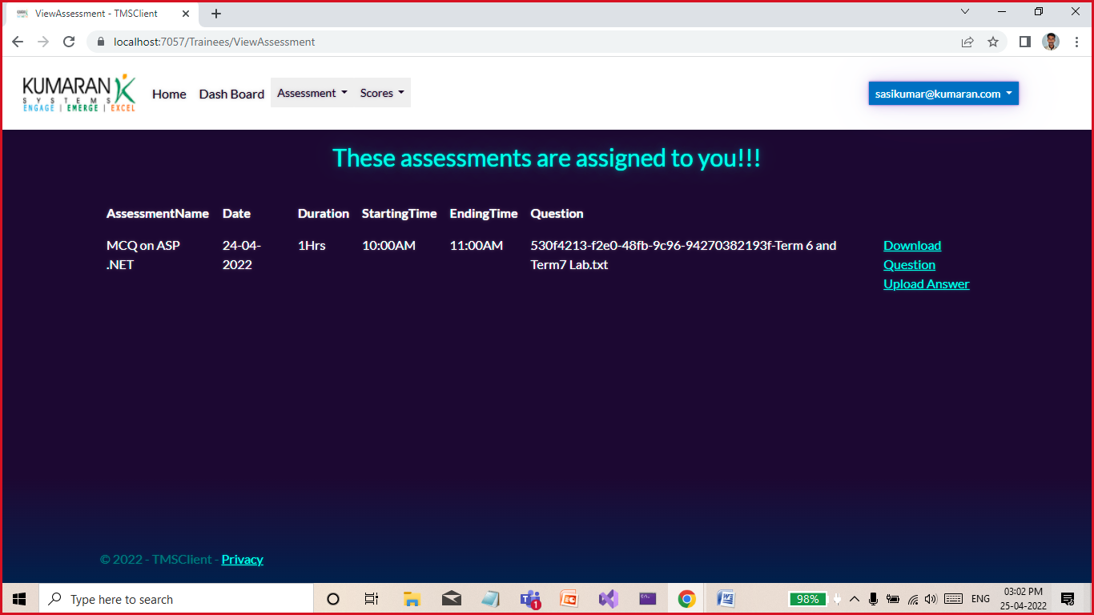

Here, download the question paper and upload the answer script. Once answer uploaded trainer will evaluate these answer scripts

Score page helps to show the trainee’s performance for all assessment happened till now.

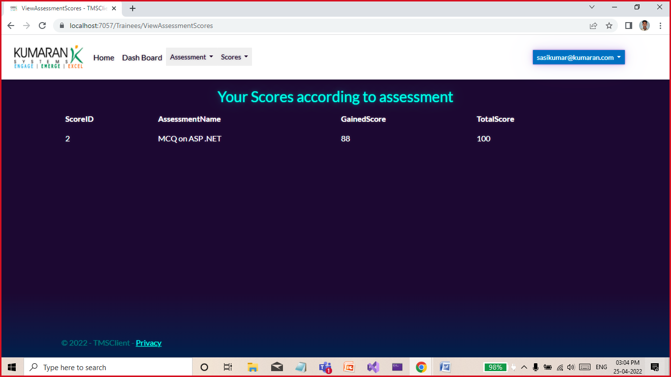

Thank you!